考试范围：平时作业内容，本大纲。

携带：洁净的热力学表、计算器。

考试准备：不建议不加个人思考的借用和拷贝（性质相同的错误双倍扣分！）。

答题可用中文。

试题内容：判断对错（20分20题）、选择（20分10题）、证明与推导（30分）计算（30分）。

注：本大纲源于多个渠道，题目的重复不代表其更为优先。

证明、推导：必须首先绘出研究对象的热力学模型（无模型答题不得分）。

1 True or false
- A thermodynamic system is a quantity of matter with real boundaries.
- The potential energy of a system is proportional to its height.
- If a system is in thermal equilibrium with its surroundings, heat exchange is impossible to happen between the system and its surroundings.
- Work is path-independent.
- Water that is just about to vaporize is called saturated vapor.
- Water just finished evaporation is called superheated vapor.
- The first law of thermodynamics is also referred to as energy balance law.
- The properties of a steady-flow system change with time.
- There is no heat transfer and work interaction occurred in a throttling process.
- A compressor is an engineering device that increases the pressure of a fluid.
- A diffuser is a device that decreases the pressure of a fluid by slowing it down.
- The difference between a heat engine and a heat pump lies in the fact that heat engine supplies work but heat pump requires work input.
- A low temperature heat reservoir to which heat is transferred is sometimes called a heat sink.
- An isobaric process keeps its pressure constant.
- The quality X of a saturated mixture is possible to be larger than 1.
- The efficiency of a reversible Carnot cycle is less than an irreversible Carnot cycle.
- Quality is defined as the ratio of the mass of saturated liquid to that of the saturated vapor coexisting in saturated mixture.
- A system called an isolated system if energy crosses its boundary but no mass exchange between the system and its surroundings.
- The total energy of a system is made up with its internal energy, kinetic energy and potential energy.
- When a system goes through a cycle, the system has an identical initial state and a final state.
- For engineering thermodynamics calculations, gage pressure other than absolute pressure was used.
- A negative sign is assigned to a system if it expands.
- The mass, pressure, temperature or internal energy of a steady-flow process do not change.
- Water below its boiling point is called as sub-cooled water or compressed water.
- Water just ready to condensate is called saturated liquid.
- The three regions of water on T-V diagram are the sub-cooled liquid region, the saturated mixture region and the superheated region.
- Quality is defined as the ratio of the mass of saturated liquid to that of the saturated vapor coexisting in saturated mixture
- A turbine is a device that decreases the pressure of a fluid and exports work through shaft
- Throttling valves are flow-restricting devices that cause a significant pressure drop in the fluid
- COP of a heat pump is possible to be larger that 100%
- Thermal efficiency of a heat engine is possible to be larger that 100%
- Heat sink can absorb heat but increase in its temperature
- Energy balance for a closed system can be explained as : ∆E_{sys} = E_{in} – E_{out}
- A compressor is an engineering device that increases the pressure of a fluid
- Heat exchange may take place in a closed system but not mass exchange
- An isothermal process is a process which can hold its temperature steady
- If a system expands, the work is done by the system, and thus work is done to the surroundings, it gives a positive sign
- When heat is added to a system, the heat is assigned negative
- Evaporation is a phase shift from liquid to vapor
- Holding the pressure constant, if temperature is extensively raised, superheated vapor can be turned into saturated mixture, and even further to subcooled liquid
- If the pressure is known, the system temperature is at saturated temperature and the specific volume is larger than V_{g}, then we can conclude that the state of the system is superheated vapor
- Total energy brought in by 1 kg of mass flowing into a control volume is : u+pv
- A diffuser is a device that decreases the pressure of a fluid by slowing it down
- The crucial feature of an energy reservoir is that it can supply or absorb heat without any effect on its temperature
- COP of a refrigerator is possible to be larger than 100%
- Carnot cycle is made up of two isothermal processes and two adiabatic processes
- A heat engine is a thermodynamic system operating in a thermodynamic cycle to which net heat is transferred and from which net work is delivered.
- The thermal efficiency is the index of performance of a work-producing device or a heat engine and is defined by the ratio of the net work output (the desired result) to the heat input (the costs to obtain the desired result).
- Heat exchange as well as mass exchange can both take place in an open system
- An isobaric process keeps its pressure constant
- An isothermal process is a process which can hold its temperature steady
- Heat, work and mass exchanges may take place in a steady flow process, but properties at each position within the system remains constant
- Saturated vapor is a state that the steam is just ready to condensate
- The quality X is possible to be larger than 1
- Throttling valves are flow-restricting devices that cause a significant pressure drop in the fluid
- A heat pump is a thermodynamic system operating in a thermodynamic cycle that removes heat from a low-temperature body and delivers heat to a high-temperature body.
- The energy balance of a control volume in a steady-flow process requires that the total energy entering the system equals that leaving the system, while the properties and the total energy inside the system keep constant.
- A system may supply energy in both forms of heat and work, but the second law of thermodynamics proves that work is higher graded than heat, therefore work output from the system is more highly evaluated in the engineering society.
- A system is said to be in the dead state when it is in thermodynamic equilibrium with its surroundings.
- When a system is at its dead state it is in both thermal and mechanical equilibrium with its surroundings.
- A system in its dead state has zero kinetic and potential energy relative to its surroundings.
- A dead state system should have no internal heat inside.
- Work can be explained as a function of both the states and path, i.e. Work= f (initial state, process path, final state), similarly, Entropy can also be explained in the same way, i.e. Entropy = f (initial state, process path, final state).
- If the work output from a process need to be maximized, we should make sure that the following 2 requirements be satisfied: (1) the process to be executed is reversible, and (2) the final state is a dead state. But this violate the 2nd law of thermodynamics.
- A system will deliver the maximum possible work as it undergoes a reversible process from the specified initial state to the state of its surroundings, i.e., the dead state.
- Exergy does not represent the amount of work that a work-producing device will actually deliver upon installation. Rather, it represents the upper limit on the amount of work a device can deliver without violating any thermodynamics laws.
- The difference between exergy and the actual work delivered by a device represents the room Engineers have for improvement.
- Exergy is a property of the combined system (the system and its surroundings) and not of the system alone.
- From the statements of the Second Law of thermodynamics, the heat Qc is a degraded amount of energy wasted to the Cold reservoir, this is the amount of cost necessary for converting part of heat into work.
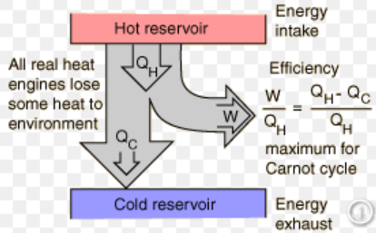

2 Chosing a correct answer

1) Which of the following is not true about a Carnot cycle?
a) The entropy creation is zero.
b) It provides a measure of the best we can hope to do.
c) It operates between two constant temperature reservoirs.
d) Two of the processes are adiabatic.
2) Which of the following is an extensive property?
a) temperature b) density c) pressure d) mass
e. none are extensive properties.
3) u + Pv is
a) a convenience function called specific entropy.
b) flow work.
c) internal energy for systems with mass flows.
d) the definition of specific enthalpy.
e) energy stored in a system.
4) A good approximation for a stream flowing through a heat exchanger is
a) h_{in} = h_{out} b) P_{in} = P_{out} c) T_{in} = T_{out} d) a and b e) b and c
5) A Carnot refrigeration cycle operates between -10 ºC and 23 ºC. What is its coefficient of performance ?
a) 1.3 b) 3.7 c) 4.5 d) 7.9 e) 8.9
6) A vapor and a liquid can coexist
- only at the triple point
- only above the critical pressure
- only below the triple point temperature
- only above the critical temperature
- below the critical temperature
7) Clasius statement for the second law of thermodynamics is that
a) energy has a quantity as well as quality
b) energy can change from one form to another
c) energy transfer has a direction
d) it is impossible to extract heat from a low temperature source without cost
8) A good approximation for a stream flowing through a capillary tube is
a) h_{in} = h_{out} b) P_{in} = P_{out} c) T_{in} = T_{out} d) u_{in} = u_{out}
9) A system is called a closed system when
a) there is only heat exchange between the system and its surroundings
b) there is only work interactions between the system and its surroundings
c) there are both heat exchange and work interactions between the system and its surroundings
d) there are neither heat exchange nor work interactions between the system and its surroundings
10) Characteristics of Heat Engines include
a) They receive heat from a high-temperature source.
b) They convert part of this heat to work.
c) They reject the remaining waste heat to low-temperature sink.
d) They operate on a cycle.
11) Quality
a) is defined by M _{liq} /(M _{liq} + M _{vap} )
b) is defined by v = x v_{f} + (1-x) v_{g}
c) equals zero for a saturated vapor.
d) is only defined in the two phase region.
e) is the fraction of mass that is liquid.
12) Extensive properties
a) apply at a point.
b) do not depend on the size of the system.
c) depend on position within a system.
d) are proportional to the mass of a system.
e) are printed in the tables in the back of your book.
13) The thermal efficiency of a heat engine
a) depends only on T _{H} and T _{C}
b) is the fraction of accepted heat that is converted into work.
c) can never equal 1.0
d) a and b
e) b and c
14) u + Pv is
a) a convenience function called specific entropy.
b) flow work.
c) internal energy for systems with mass flows.
d) the definition of specific enthalpy.
e) energy stored in a system.
15) The flow work is associated with the energy interactions of mass flow through an open system, if the pressure and the specific volume are known both at the inlet and the outlet of the system, the flow work is defined, in view of 1 kg of mass flow, as
a) p₁v₁+p₂v₂ b) p₁v₁-p₂v₂ c) p₂v₂-p₁v₁ d) any of a, b, or c
16) Characteristics of a refrigerator include
- They receive heat from a high-temperature source.
- They convert part of this heat to work.
- They reject the remaining waste heat to low-temperature sink.
- They operate on a cycle.
17) The total energy absorbed by a constant pressure evaporation process or the total energy released from a constant pressure condensation process is expressed by the change of
a) internal energy b) work c) enthalpy d) heat
18) A thermodynamic system generally has a boundary, this boundary
a) can be personally defined from your own interests
b) can only be defined following certain roles
c) is depend on the physical boundaries
d) is independent on the physical as well as personal wills
19) A system is called a closed system when
a) there is only heat exchange between the system and its surroundings
b) there is only work interactions between the system and its surroundings
c) there are both heat exchange and work interactoins between the system and its surroundings
d) there are neither heat exchange nor work interactions between the system and its surroundings
20) The specific internal energy, u, other than U, of a system is determined by the of the system
a) volume b) pressure c) temperature d) mass
21) An example of internal property of a system is
a) mass b) total volume c)pressure d) enthalpy
22) The state of a system is generally specified by its properties, of which it should be
a) any one of the pressure, the total volume, or the temperature
b) any two of the pressure, the total volume, or the temperature
c) any two of the pressure, the specific volume, or the temperature
d) all the three of the pressure, the specific volume, and the temperature
23) A steady state process is related to
a) a closed system with invarible properties b) a control volume with its property changes
c) an open system keeping its properties constant d) a closed system having its properties changed
24) A good approximation for a stream flowing through a porous plug is
a) h_{in} = h_{out} b) P_{in} = P_{out} c) T_{in} = T_{out}
d) a and b e) b and c
25) ΔT= 0 is true
a) for an adiabatic process. B) if no work is done.
c) for an isentropic process. D) for a reversible process.
26) Characteristics of Heat Engines include
a) They receive heat from a high-temperature source.
b) They convert part of this heat to work.
c) They reject the remaining waste heat to low-temperature sink.
d) They operate on a cycle.
27）The boundary of a system is either fixed or movable, but when boundary work happens, it is required that
a) The boundary is fixed b) The boundary is movable
c) The boundary is either fixed or movable
d) There is no special demand on the movement of the boundary
28） The flow work is associated with the energy interactions of mass flow through an open system, if the pressure and the specific volume are known both at the inlet and the outlet of the system, the flow work is defined, in view of 1 kg of mass flow, as
a) p₁v₁+p₂v₂ b) p₁v₁-p₂v₂ c) p₂v₂-p₁v₁ d) any of a, b, or c
29）To facilitate heat exchange between a system and its surroundings,
- there should be temparature differences between the system and its surroundings
- the temperature of the system should be higher than that of the surroundings
- the pressure of the system should be different from that of its surroundings
- the pressure of the system should be higher than that of its surroundings
30） When a system goes through a process, its starts from an initial state and ends up with a final state which is exactly the same condition with the initial state, such a process is invariably named as
a path process b) a point process c) a cycle d) a working process
31）To facilitate interaction of boundary work between a closed system and its surroundings,
- there should be temperature differences between the system and its surroundings
- the temperature of the system should be higher than that of the surroundings
- the pressure of the system should be different from that of its surroundings
- the pressure of the system should be higher than that of its surroundings
32）Characteristics of a refrigerator include
- They receive heat from a high-temperature source.
- They convert part of this heat to work.
- They reject the remaining waste heat to low-temperature sink.
- They operate on a cycle.
33）Clausius statement for the second law of thermodynamics is that
a) energy has a quantity as well as quality b) energy can change from one form to another
c) energy transfer has a direction
d) it is impossible to extract heat from a low temperature source without cost

34) The Kelvin-Plank statement of the second law of thermodynamics says that
a) It costs to move heat from heat sink to heat source.
b) It does not cost to move heat from heat sink to heat source.
c) It is possible to convert all the heat drawn from a heat source to work.
d) It is impossible to convert all the heat drawn from a heat source to work.

35) Both Kelvin-Plank and Clausius statements of the second law of thermodynamics state the fact that
a) Heat is highly graded as compared with work.
b) Work is highly graded as compared with heat.
c) Work to heat transfer is harder to be fulfilled as compared with heat to work transfer.
d) Heat to work transfer is an autonomous process that can be occurred in the nature.

34）The total energy absorbed by a constant pressure evaporation process or the total energy released from a constant pressure condensation process is expressed by the change of
a) internal energy b) work c) enthalpy d) heat
35）A good approximation for a stream flowing through a capillary tube is
a) h_{in} = h_{out} b) P_{in} = P_{out} c) T_{in} = T_{out} d) u_{in} = u_{out}

36) A vapor and a liquid can coexist
a) only at the triple point
b) only above the critical pressure
c) only below the triple point temperature
d) only above the critical temperature
e) below the critical temperature

37) What is the efficiency of an ideal Carnot heat engine cycle operating between 38 ºC and 482 ºC ?
a) 90 %
b) 89 %
c) 59 %
d) 16 %
e) 11 %
38) A Carnot refrigeration cycle operates between -10 ºC and 23 ºC. What is its coefficient of performance ?
a) 1.3
b) 3.7
c) 4.5
d) 7.9
e) 8.9
39) A good approximation for a stream flowing through a heat exchanger is
a) h_{in} = h_{out}
b) P_{in} = P_{out}
c) T_{in} = T_{out}
d) a and b
e) b and c
40) In an adiabatic process:
a) temperature cannot change.
b) there is no heat flow.
c) internal energy cannot change.
d) a and b
e) a, b and c
41) The term in the general energy balance accounts for
a) shaft power
b) power due to moving solid boundaries on the control volume.
c) power necessary to push mass into and out of the control volume.
d) a, b and c
e) a and b
f) a and c
42) The thermal efficiency of a heat engine
a) depends only on T_{H} and T_{C}
b) is the fraction of accepted heat that is converted into work.
c) can never equal 1.0
d) a and b
e） b and c
43） u + Pv is
a） a convenience function called specific entropy.
b) flow work.
c) internal energy for systems with mass flows.
d) the definition of specific enthalpy.
e) energy stored in a system.
44) Which of the following is not true about a Carnot cycle?
a ) It consists of two reversible and two irreversible processes.
b) It provides a measure of the best we can hope to do.
c) It operates between two constant temperature reservoirs.
d) Two of the processes are adiabatic.
e) The entropy creation is zero.
46） A steam turbine receives 550 kPa steam with an enthalpy of 2955 kJ/kg. The turbine exhausts to 175 kPa and the exhaust steam has an enthalpy of 2765 kJ/kg. What is the energy used by the turbine ?
- 13132 kJ/kg
- 190 kJ/kg
- 263 kJ/kg
- 12890 kJ/kg
- none of the above
47）Which of the following is an extensive property ?
- temperature
- weight
- composition
- pressure
- none of the above

3 Applications and Calculations
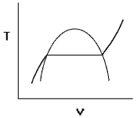
1) Label (by letter) each of the following on the figure below:
a. critical point
b. isobar
c. subcooled liquid region
d. superheated vapor region
e. saturated liquid curve
f. saturated vapor curve

2) A throttling calorimeter is a device for determining the quality of a two-phase liquid-vapor mixture.
Inlet: saturated mixture, p₁ = 2 MPa,
Exit: T₂ = 150 ºC, p₂ = 100 kPa,
Find the quality of water at the inlet.

- Steam enters an adiabatic turbine steadily at 6 MPa and 600ºC,
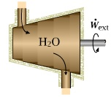
50 m/s, and exits at 50 kPa, 100ºC, 150 m/s. The turbine
produces 5 MW.
Determine the mass flow rate. Neglects p_{e}.

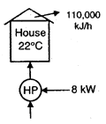
- A heat pump maintains a house at a specified temperature (22ºC).
The atmospheric temperature is 2ºC. The rate of heat loss
of the house and the power consumption of the heat
pump are given. It is to be determined if this heat
pump can do the job.

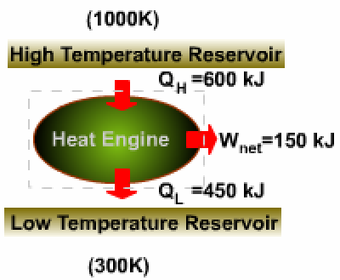
5) A heat engine receives 600 kJ of heat from a high-temperature source at 1000 K during a cycle. It converts 150 kJ of this heat to work and rejects the remaining 450 kJ to a low-temperature sink at 300 K.
Determine if this heat engine violates the second law thermodynamics on the basis of
- the Clausius inequality, and/or
- the Carnot principle

6）Steam enters an nozzle operating at steady state at 5 MPa, 350ºC, 10 m/s and exits at 2 MPa and 267ºC. The steam flows through the nozzle with negligible heat transfer and pe. The mass flow rate is 2 kg/s.
Determine (a) the exit velocity and (b) the exit area.
7） Steam enters an adiabatic turbine steadily at 2.5 MPa and 450 ºC, and exits at 60 kPa, 100ºC. If the power output of the turbine is 3 MW。
Determine the mass flow rate。
8) A heat pump is to be used to heat a building during the winter. The building is to be maintained at 21ºC at all times. The building is estimated to be losing heat at a rate of 135,000 kJ/h when the outside temperature drops to -5 ºC. Determine the minimum power required to drive the heat pump unit for this outside temperature. （The heat lost by the building has to be supplied by the heat pump）.
9) A rigid, insulated tank that is initially evacuated is connected through a valve to a supply line that carries steam at 1 MPa and 300°C. Now the valve is opened, and steam is allowed to flow slowly into the tank until the pressure reaches 1 MPa, at which point the valve is closed. Determine the final temperature of the steam in the tank.

10) Explain the following terms

- Isolated system
- Flow work
- Isothermal process
- Carnot principle
- Heat pump
- Saturated mixture
- Superheated vapor
- Evaporation
- Saturated air
- Nozzle

- Open system
- Boundary work
- Heat sink
- Subcooled liquid
- Saturated vapor
- Condensation
- Latent heat
- Dry air
- Pump
- Compressor
- Enthalpy (in an isobaric evaporation process)
- Enthalpy (in a steady-flow process)
- Internal energy
- Flow work
- Dead state
- Exergy

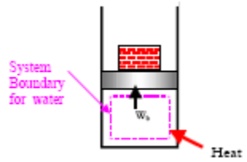
11）What made up of the total energy of a system?
12）State the Second law of thermodynamics

13) What the power cycle is explained in the diagram? How can we improve the efficiency?
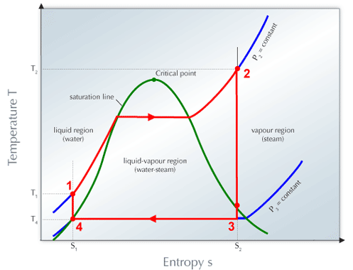
14) What the cycle is explained in the figure? Derive the Entropy from this process.
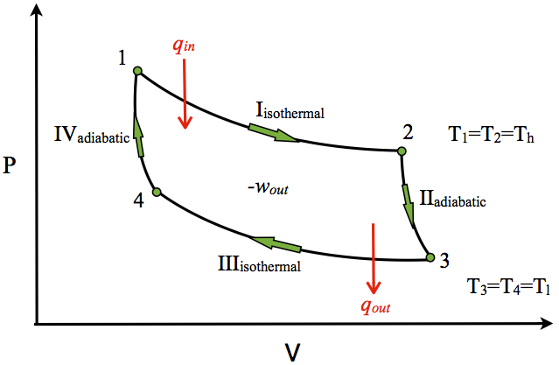

15) What this model, proposed by Kelvin, is used for? Explain the Theorem it relies on and the results it yields.
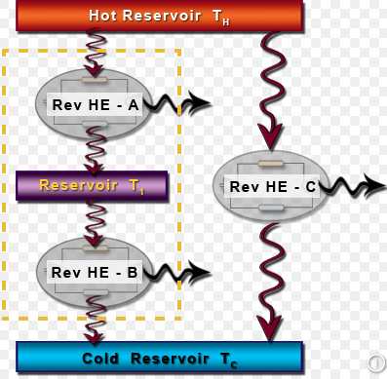

16) There are several ways to improve the performance of a Rankine cycle. Please reference to the T-S diagram and make your own illustration on how to improve the performance of the cycle. With respect to each improvement, please explain what the modifications should be made on the physical constructions.
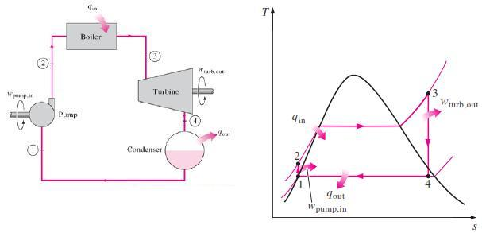

17）Draw two constant pressure evaporation processes in T-V diagrams, one for 0.6 atmospheric pressure and the other is for 0.8 atmospheric.
18）Water is placed in a piston-cylinder device at 20 °C, 0.1 MPa. Weights are placed on the piston to maintain a constant force on the water as it is heated to 400 °C. How much work does the water do on the piston?
19）The power output of an adiabatic steam turbine is 5 MW, and the inlet and the exit conditions of the steam are as indicated in See Fig..
Calculate the mass flow rate of the steam.

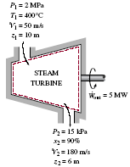
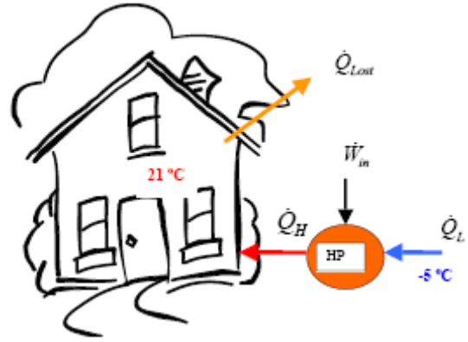
20）A heat pump is to be used to heat a building during the winter. The building is to be maintained at 21ºC at all times. The building is estimated to be losing heat at a rate of 135,000 kJ/h when the outside temperature drops to -5 ºC. Determine the minimum power required to drive the heat pump unit for this outside temperature.
The heat lost by the building has to be supplied by the heat pump.

21) Give an evaporation process (under constant pressure) on P-T diagram
18) Give the proof of energy balance equation for a capillary tube
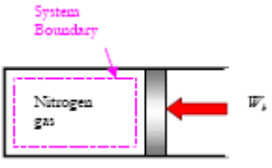
22) Draw a p-v diagram to illustrate a Carnot cycle
23) Three kilograms of nitrogen gas at 27°C and 0.15 MPa are compressed isothermally to 0.3 MPa in a piston-cylinder device. Determine the minimum work of compression, in kJ.

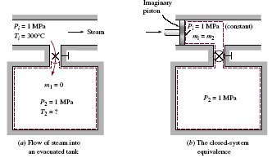
24) A rigid, insulated tank that is initially evacuated is connected through a valve to a supply line that carries steam at 1 MPa and 300°C. Now the valve is opened, and steam is allowed to flow slowly into the tank until the pressure reaches 1 MPa, at which point the valve is closed. Determine the final temperature of the steam in the tank.
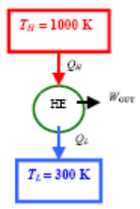
25) An inventor claims to have invented a heat engine that develops a thermal efficiency of 80 percent when operating between two heat reservoirs at 1000 K and 300 K.
Evaluate his claim.
26) Derive the energy balance equation for a turbine
27) Derive the energy balance equation for a capillary tube
28) Derive the energy balance equation for a nozzle
29) Explain what is the flow work of a control volume
30) Prove the Clausius inequality theorem
31) Prove the entropy increase law for a closed system (start from Clausius Inequality).
32) Explain how and why the entropy is defined as a fundamental physical property.
33) Prove Carnot Principle I.
34) Prove Carnot Principle II.
35) Prove that a system violating Kelvin-Plank statement can also violate Clausius statement.
36) Calculate the thermal efficiency of the power cycle below.

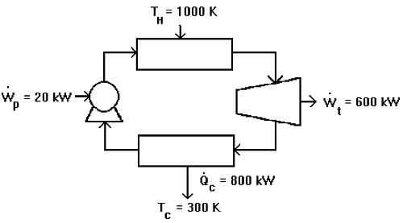

37) A steam at 200 kPa enters a heat exchanger as saturated vapor and leaves as saturated liquid in a flow rate of 2 kg/s. Heat from the steam is taken up by a coolant liquid (Cp = 5.0 kJ/kg K) which enters at 25 oC and leaves at 40 oC. Determine the required flow rate of the coolant.
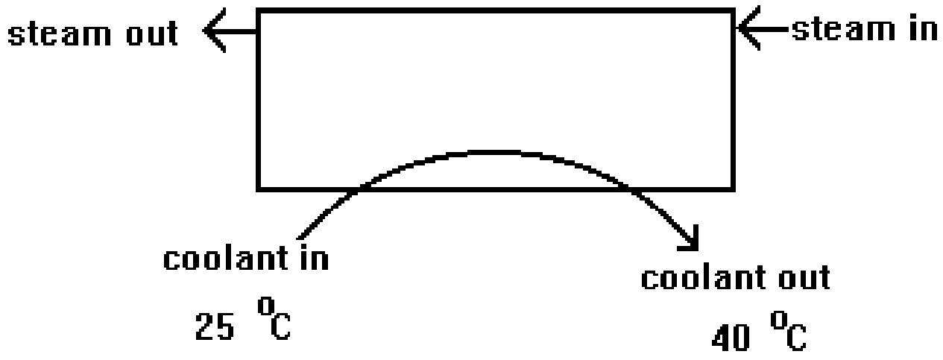

38）The figure illustrated the T-V diagram of a Rankine cycle. Each turning point was numbered, i.e. from 1 to 6. Please answer the following questions:
(1) which process is occurred in the turbine ? (give the number list, e.g. 5→6→1)
(2) which path is contributed by the pump? (give the number list, e.g. 5→6→1)
(3) when the performance of the cycle needs to be improved, what is your option for the improvement ? Please draw dashed lines on the diagram for the illstration.
(4) in case 500 kW of electric power is required, and the known steam supply from the boiler has a pressure of 5 Mpa and a temperature of 400 ℃. The exhaust from the turbine has a pressure of 100 kPa and a quanlty of 0.4. Calculate how much the steam flow rate is required.

